Imported ova file to setup VM machine.

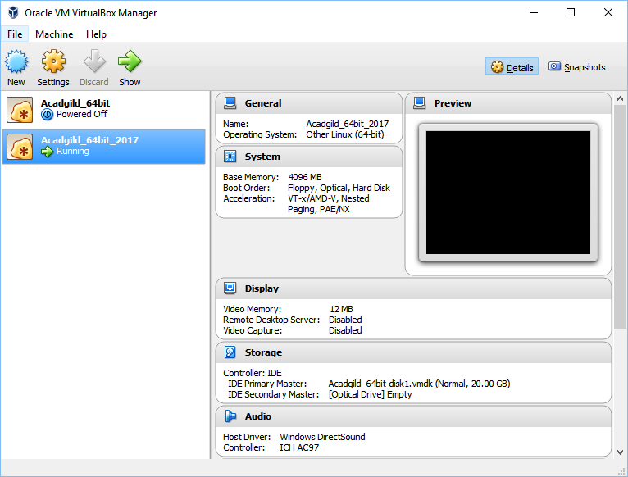

Configured the RAM to 4096 from default 1024 and started linux acadgild sandbox.

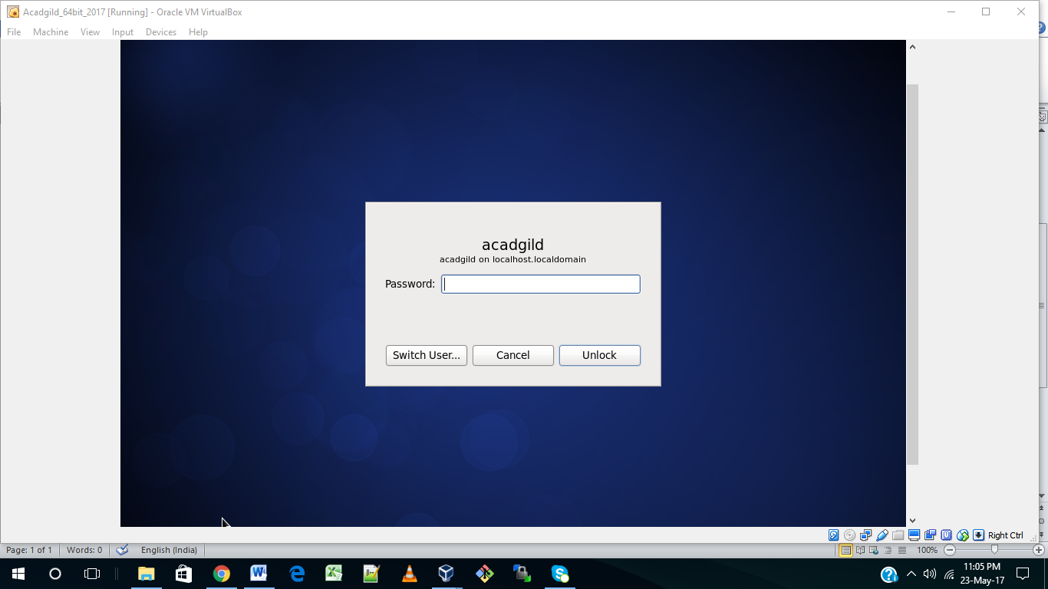

Command **jps** to see java processes

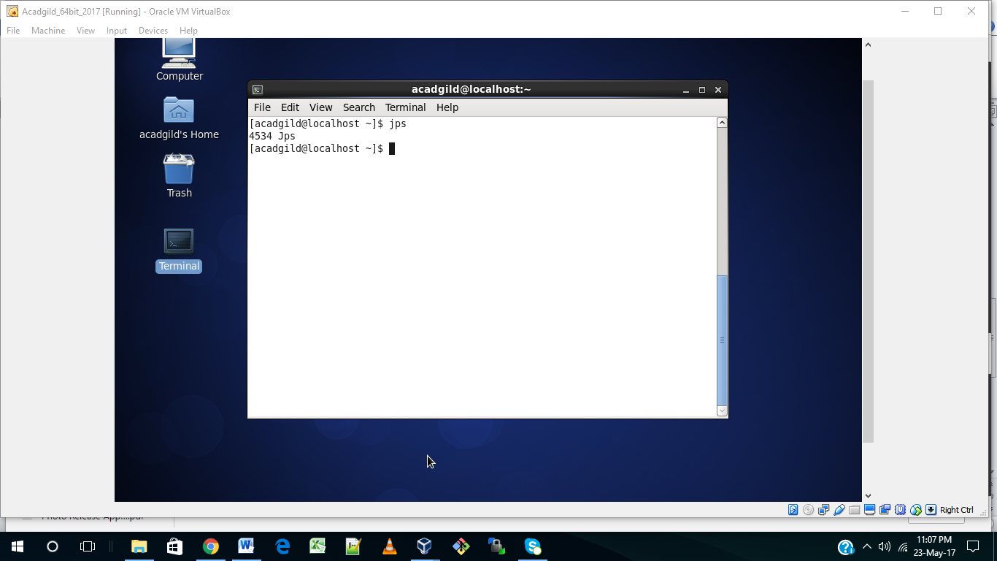

Command **sudo service sshd start**

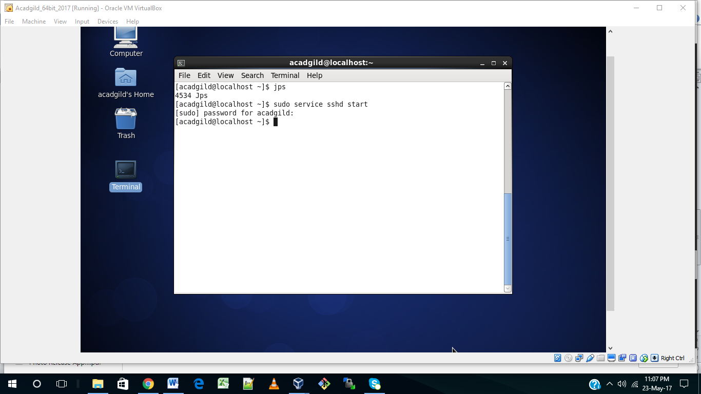

Command **start-all.sh** to start all services

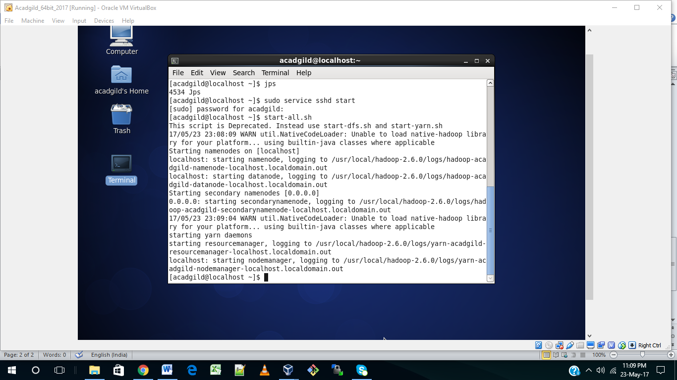

Command **mr-jobhistory-daemon.sh start historyserver** to start history server for job logs.

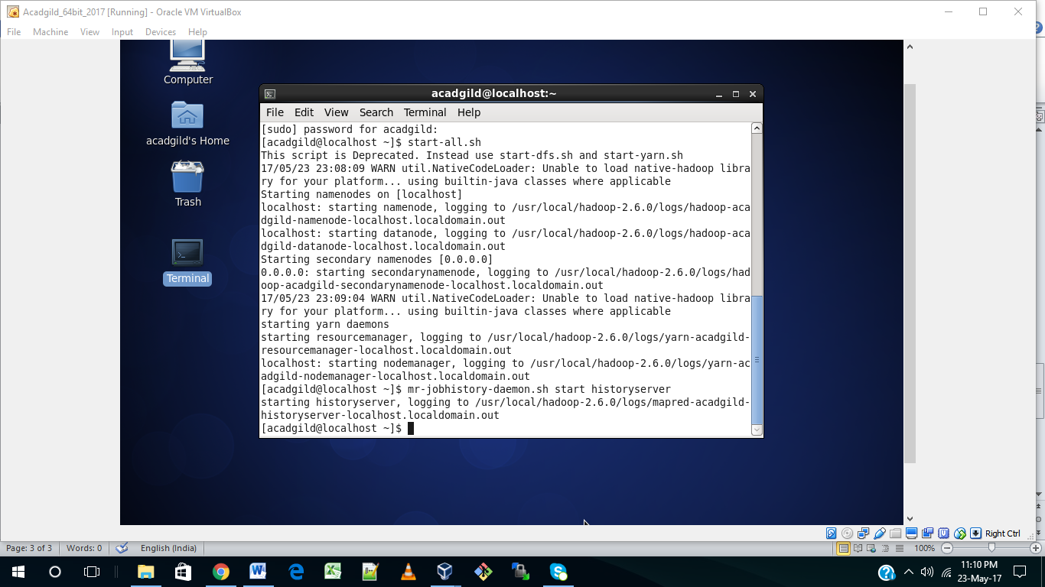

Command **pig** to start pig using grunt shell.

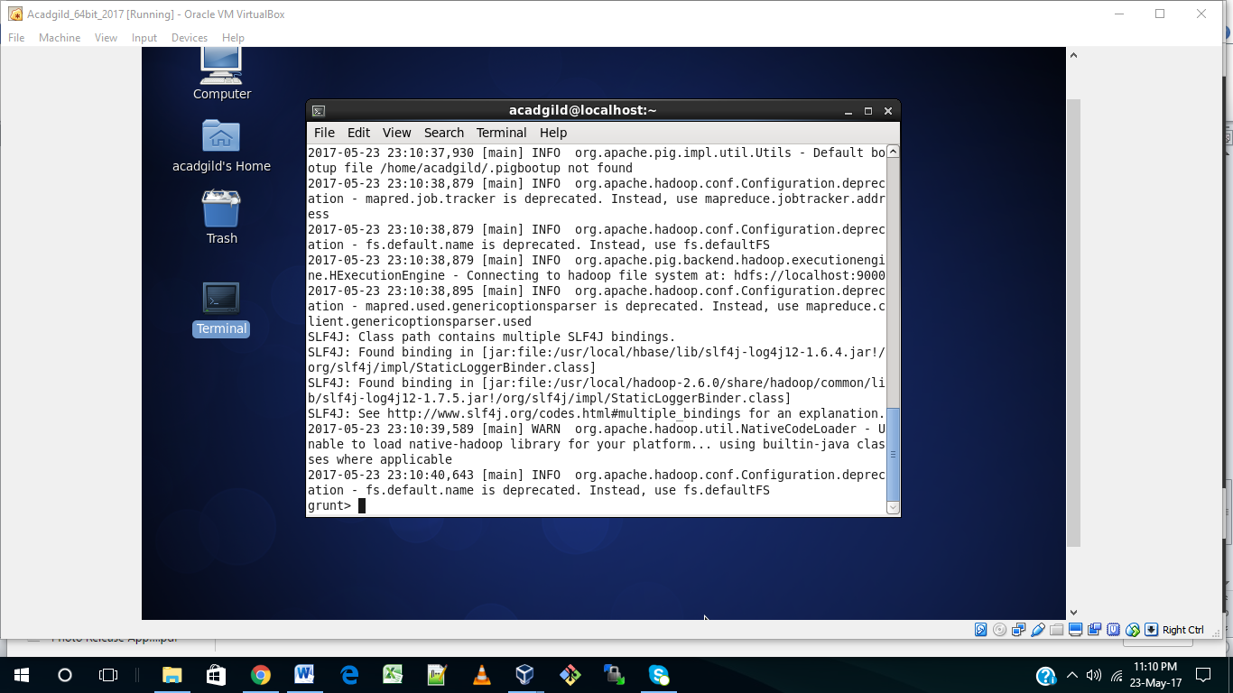

Command **sudo service mysqld start** to start mysql service.

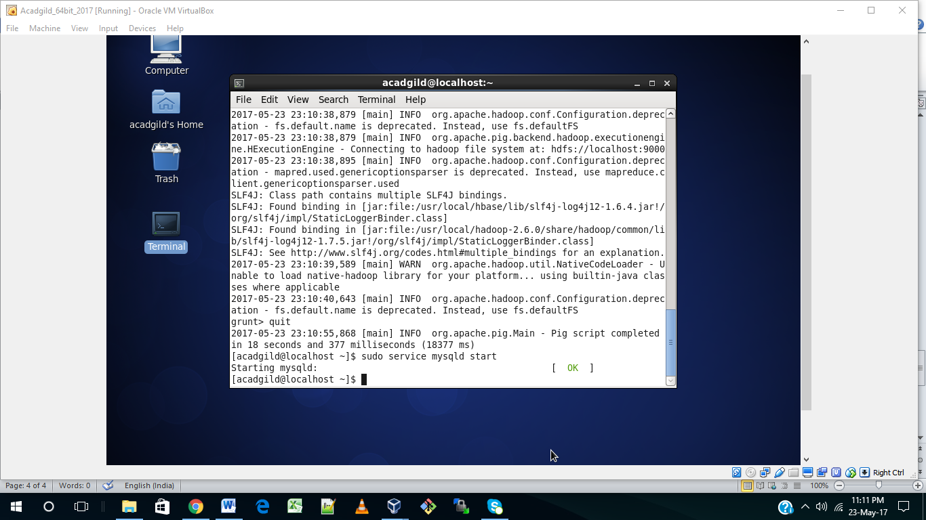

Command **hive**

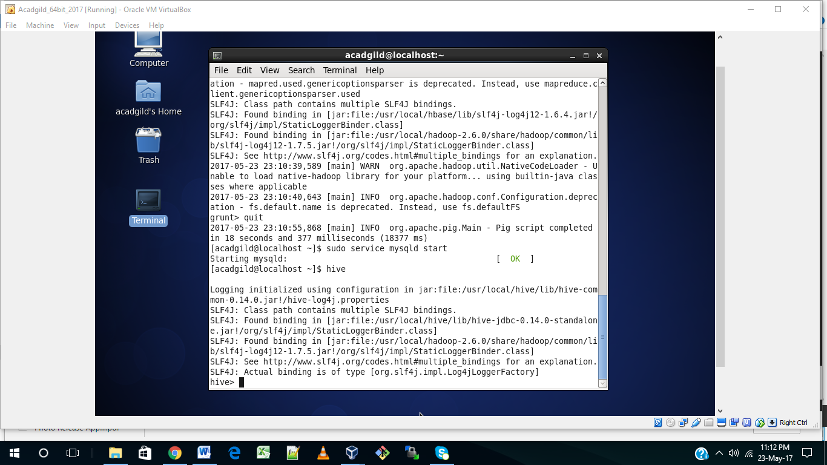

Command **start-hbase.sh**

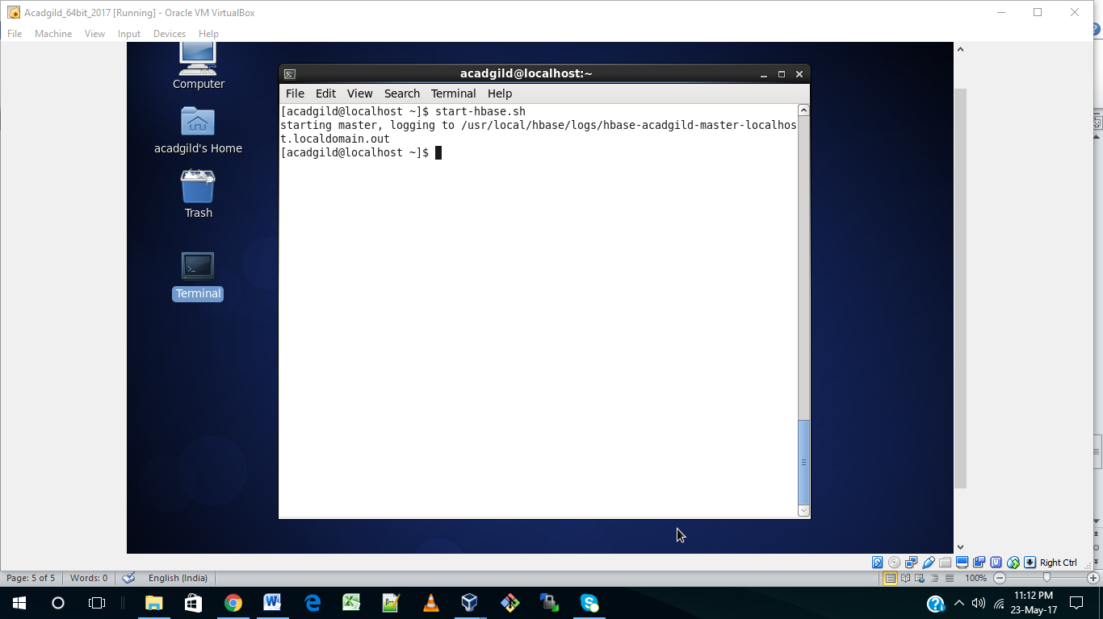

Command **stop-all.sh** to stop all services

